Chapter 11 homework

- Reproduce the example on p. 427-9 of KNN
  - KNN uses my "method #4" for obtaining the weights
  - Try putting the data into 5 groups to obtain weights also; compare these results to those obtained by KNN
- Complete exercises
  - 11.11: Instead of b.-e., use LMS and LTS to fit the model and plot it; compare the estimates to least squares
  - 11.25
    - For part b: Use a 3D plot instead of a contour plot; examine a full second-order model as well
    - For part c: Use loess() with q = 9/25
    - For part d: Use a 3D plot instead and make sure to put it on the same scale as in b for comparison purposes
- Reproduce all examples in the notes

Partial answers:

Reproduce the example on p. 427 of KNN. Below is my R code and output.

> set1<-read.table(file = "C:\\chris\\UNL\\STAT870\\Instructor_CD\\Data
Sets\\Chapter 11 Data Sets\\CH11TA01.txt",
header = FALSE, col.names = c("X", "Y"), sep = "")
> #Check first few observations
> head(set1)
X Y
1 27 73
2 21 66
3 22 63
4 24 75
5 25 71
6 23 70

> #Regular least squares
> mod.fit<-lm(formula = Y ~ X, data = set1)
> summary(mod.fit)

Call:
lm(formula = Y ~ X, data = set1)

Residuals:
Min 1Q Median 3Q Max
-16.47859 -5.78765 -0.07844 5.61173 19.78132

Coefficients:
Estimate Std. Error t value Pr(>|t|)
(Intercept) 56.15693 3.99367 14.061 < 2e-16 ***
X 0.58003 0.09695 5.983 2.05e-07 ***
---
Signif. codes: 0 '***' 0.001 '**' 0.01 '*' 0.05 '.' 0.1 ' ' 1

Residual standard error: 8.146 on 52 degrees of freedom
Multiple R-Squared: 0.4077, Adjusted R-squared: 0.3963
F-statistic: 35.79 on 1 and 52 DF, p-value: 2.050e-07

> par(mfrow = c(1,3), pty = "s")
> #Y vs. X with sample model
> plot(x = set1$X, y = set1$Y, xlab = "X", ylab = "Y", main = "Y vs. X",
panel.first = grid(col = "gray", lty = "dotted"))
> curve(expr = mod.fit$coefficients[1] + mod.fit$coefficients[2]*x, col = "red",
lty = "solid", lwd = 2, add = TRUE, from = min(set1$X), to = max(set1$X))

> #Residuals vs. Y^
> plot(x = mod.fit$fitted.values, y = mod.fit$residuals, xlab = expression(hat(Y)),
ylab = "Residuals", main = "Residuals vs. estimated mean response",
panel.first = grid(col = "gray", lty = "dotted"))
> abline(h = 0, col = "darkgreen")

> #abs(residuals) vs. X
> plot(x = set1$X, y = abs(mod.fit$residuals), xlab = "X", ylab = "Residuals",
main = "Residuals vs. X", panel.first = grid(col = "gray", lty = "dotted"))
> abline(lm(abs(mod.fit$residuals)~set1$X), col = "red") #Quick way to get line on
plot
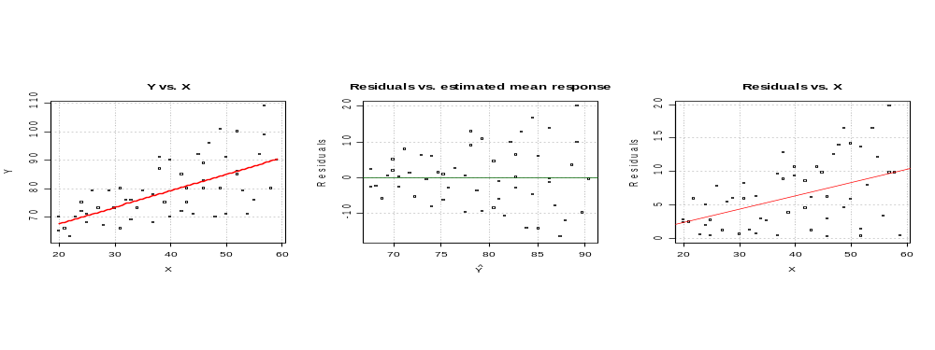
> #Examine how abs(e) is a function of X
> mod.fit.s<-lm(abs(mod.fit$residuals)~set1$X)
> mod.fit.s$coefficients
(Intercept) set1$X
-1.5494776 0.1981723

> #Table 11
> table.11<-data.frame(set1, e = mod.fit$residuals, abs.e = abs(mod.fit$residuals),
s = mod.fit.s$fitted.values, w = 1/mod.fit.s$fitted.values^2)
> head(table.11)
X Y e abs.e s w
1 27 73 1.1822391 1.1822391 3.801175 0.06920928
2 21 66 -2.3375761 2.3375761 2.612141 0.14655708
3 22 63 -5.9176069 5.9176069 2.810313 0.12661657
4 24 75 4.9223315 4.9223315 3.206658 0.09725115
5 25 71 0.3423007 0.3423007 3.404830 0.08625993
6 23 70 0.5023623 0.5023623 3.008485 0.11048521

> tail(table.11)
X Y e abs.e s w
49 50 71 -14.1584692 14.1584692 8.359138 0.014311232
50 59 90 -0.3787464 0.3787464 10.142689 0.009720617
51 50 91 5.8415308 5.8415308 8.359138 0.014311232
52 52 100 13.6814692 13.6814692 8.755482 0.013044872
53 58 80 -9.7987156 9.7987156 9.944516 0.010111898
54 57 109 19.7813152 19.7813152 9.746344 0.010527289

> #Weighted least squares
> mod.fit.wls<-lm(formula = Y ~ X, data = set1, weight = table.11$w)
> summary(mod.fit.wls)

Call:
lm(formula = Y ~ X, data = set1, weights = table.11$w)

Residuals:
Min 1Q Median 3Q Max
-2.0230 -0.9939 -0.0327 0.9250 2.2008

Coefficients:
Estimate Std. Error t value Pr(>|t|)
(Intercept) 55.56577 2.52092 22.042 < 2e-16 ***
X 0.59634 0.07924 7.526 7.19e-10 ***
---
Signif. codes: 0 '***' 0.001 '**' 0.01 '*' 0.05 '.' 0.1 ' ' 1

Residual standard error: 1.213 on 52 degrees of freedom
Multiple R-Squared: 0.5214, Adjusted R-squared: 0.5122
F-statistic: 56.64 on 1 and 52 DF, p-value: 7.187e-10

> confint(mod.fit.wls, level = 0.95)
2.5 % 97.5 %
(Intercept) 50.507175 60.6243577
X 0.437339 0.7553445

Now, try putting the data into 5 groups.

> #################################################################################
> # Try putting the data into 5 groups

> #Find quantiles for Y^'s
> quant5<-quantile(x = mod.fit$fitted.values, probs = c(0.2, 0.4, 0.6, 0.8), type
= 1)
> quant5
20% 40% 60% 80%
71.81776 77.61807 81.67828 86.31853

> #Put Y^'s into groups based upon quantiles
> groups<-ifelse(mod.fit$fitted.values < quant5[1], 1,
ifelse(mod.fit$fitted.values < quant5[2], 2,
ifelse(mod.fit$fitted.values < quant5[3], 3,
ifelse(mod.fit$fitted.values < quant5[4], 4, 5))))
> var.eps<-tapply(X = mod.fit$residuals, INDEX = groups, FUN = var)
> var.eps
1 2 3 4 5
16.34516 22.13168 67.99866 113.24704 126.25498

> #Visualization of creating the groups
> par(mfrow = c(1,1), pty = "m")
> plot(x = mod.fit$fitted.values, y = mod.fit$residuals, xlab =
expression(hat(Y)), ylab = "Residuals", main = "Residuals vs. estimated
mean response", panel.first = grid(col = "gray", lty = "dotted"))
> abline(h = 0, col = "darkgreen")
> abline(v = quant5, col = "red", lwd = 3)
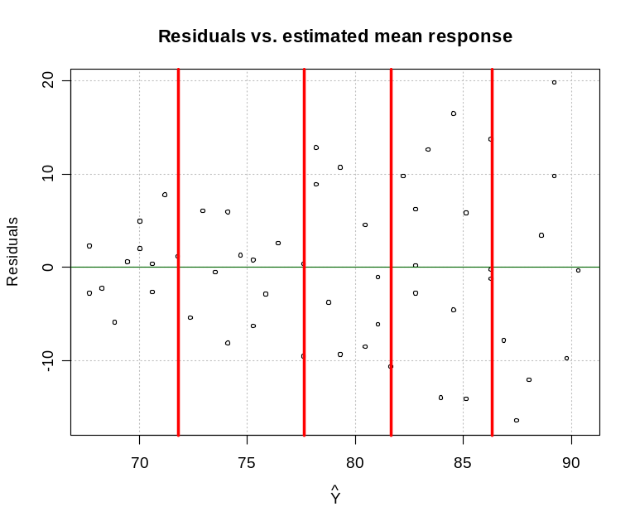

> #Put the group variances into a vector corresponding to each observation
> group.var<-ifelse(groups == 1, var.eps[1],
ifelse(groups == 2, var.eps[2],
ifelse(groups == 3, var.eps[3],
ifelse(groups == 4, var.eps[4], var.eps[5]))))

> mod.fit1<-lm(formula = Y ~ X, data = set1, weight = 1/group.var)
> summary(mod.fit1)

Call:
lm(formula = Y ~ X, data = set1, weights = 1/group.var)

Weighted Residuals:
Min 1Q Median 3Q Max
-1.72962 -0.72647 -0.00255 0.57519 1.91725

Coefficients:
Estimate Std. Error t value Pr(>|t|)
(Intercept) 56.23030 2.73635 20.549 < 2e-16 ***
X 0.57763 0.08377 6.895 7.27e-09 ***
---
Signif. codes: 0 ‘***’ 0.001 ‘**’ 0.01 ‘*’ 0.05 ‘.’ 0.1 ‘ ’ 1

Residual standard error: 0.9732 on 52 degrees of freedom
Multiple R-squared: 0.4776, Adjusted R-squared: 0.4676
F-statistic: 47.55 on 1 and 52 DF, p-value: 7.268e-09

Overall, we can see this model is similar to the previous model. The standard errors are a little larger here.

11.11 Below is my plot of the models
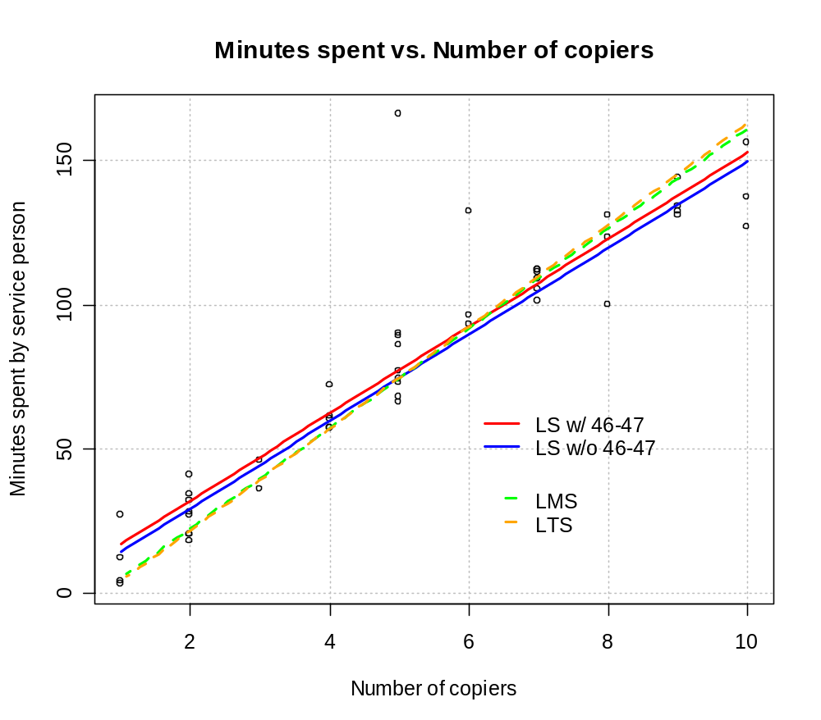
KNN using IRLS obtain a model close to the blue line. I would have expected this for LMS and LTS as well to show how they maintain the same type of relationship found without 46-47. If you obtain a different answer, please let me know.
11.25 – Note that the answer key only partially matches up with the correct answers.

The answer key is incorrect for this problem so I am just going to provide my own partial answers.

> crop.yield<-read.table(file = "C:\\chris\\UNL\\STAT870\\Instructor_CD\\Data
Sets\\Chapter 11 Data Sets\\CH11PR25.txt", header = FALSE,
col.names = c("yield", "moisture", "temperature"), sep = "")
> head(crop.yield)
yield moisture temperature
1 49.2 6 20
2 48.1 6 21
3 48.0 6 22
4 49.6 6 23
5 47.0 6 24
6 51.5 8 20

> #############################################################################
> # Regular least squares
>
> mod.fit<-lm(formula = yield ~ moisture + temperature + I(moisture^2), data =
crop.yield)
> summary(mod.fit)

Call:
lm(formula = yield ~ moisture + temperature + I(moisture^2),
data = crop.yield)

Residuals:
Min 1Q Median 3Q Max
-0.9994 -0.4691 -0.2331 0.1931 2.0569

Coefficients:
Estimate Std. Error t value Pr(>|t|)
(Intercept) 40.10114 3.58316 11.192 2.61e-10 ***
moisture 5.09514 0.51142 9.963 2.07e-09 ***
temperature -0.53000 0.12019 -4.410 0.000244 ***
I(moisture^2) -0.29286 0.02539 -11.533 1.51e-10 ***
---
Signif. codes: 0 '***' 0.001 '**' 0.01 '*' 0.05 '.' 0.1 ' ' 1

Residual standard error: 0.8498 on 21 degrees of freedom
Multiple R-Squared: 0.9372, Adjusted R-squared: 0.9282
F-statistic: 104.4 on 3 and 21 DF, p-value: 8.829e-13

- 2nd order model plotted.

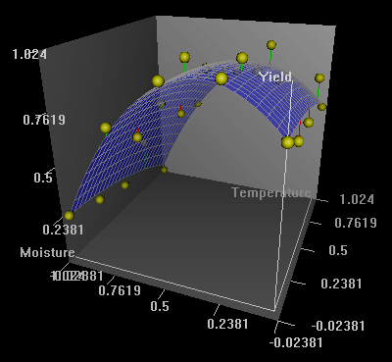

Model fit to data:
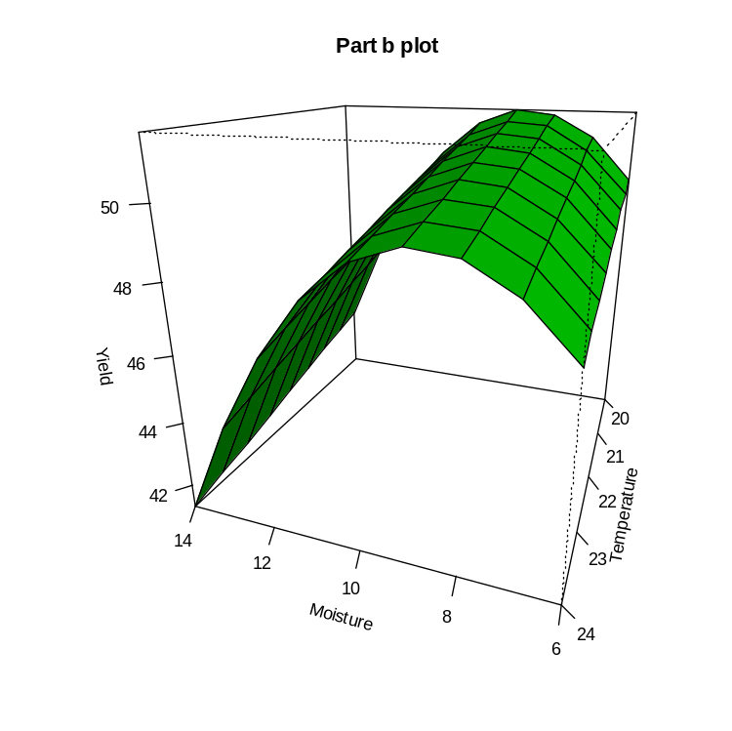

- Use loess() with loess(formula = yield ~ moisture + temperature, data = crop.yield, span = 9/25, degree = 1)

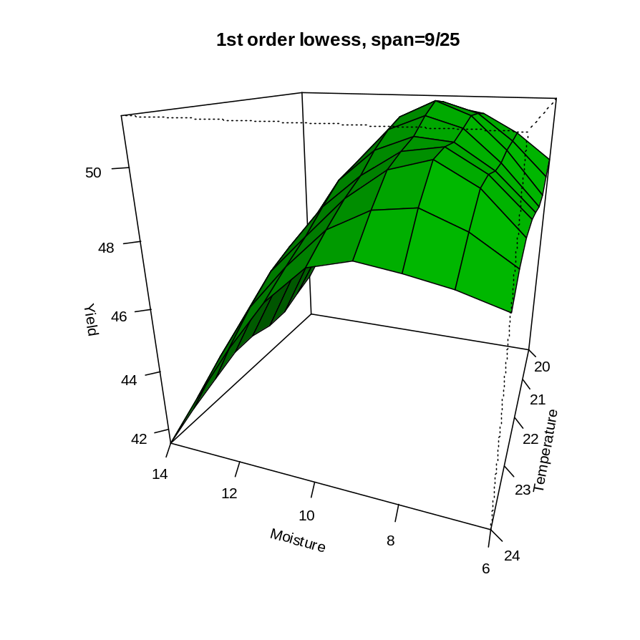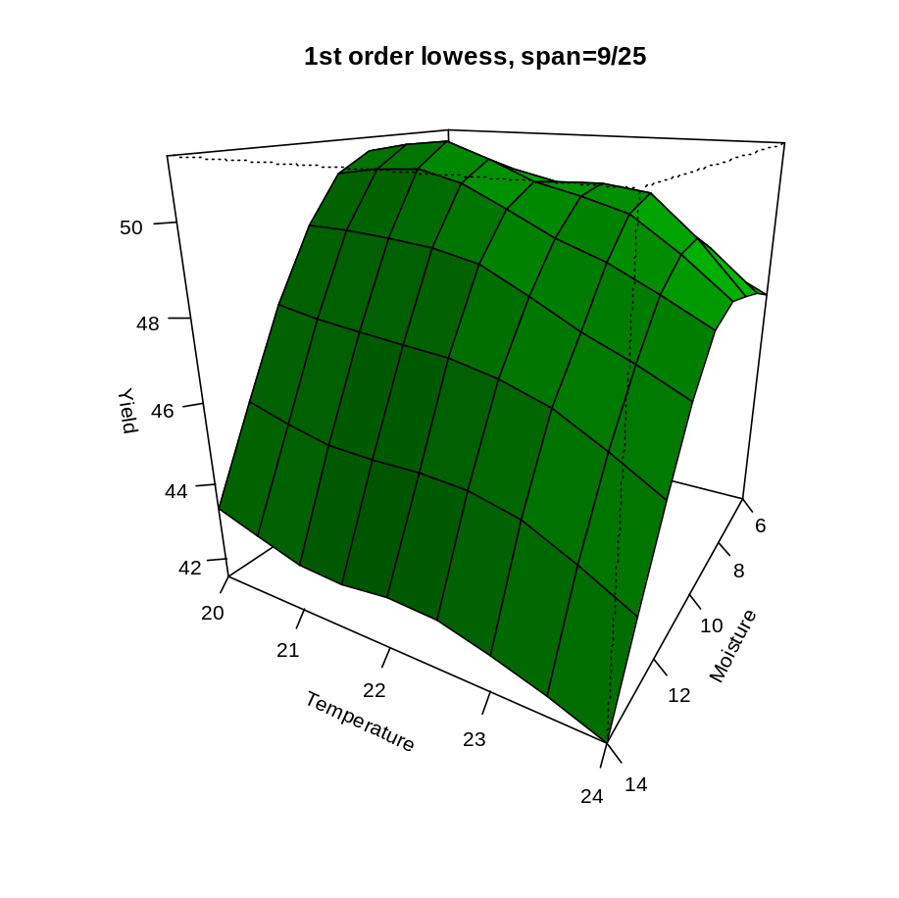

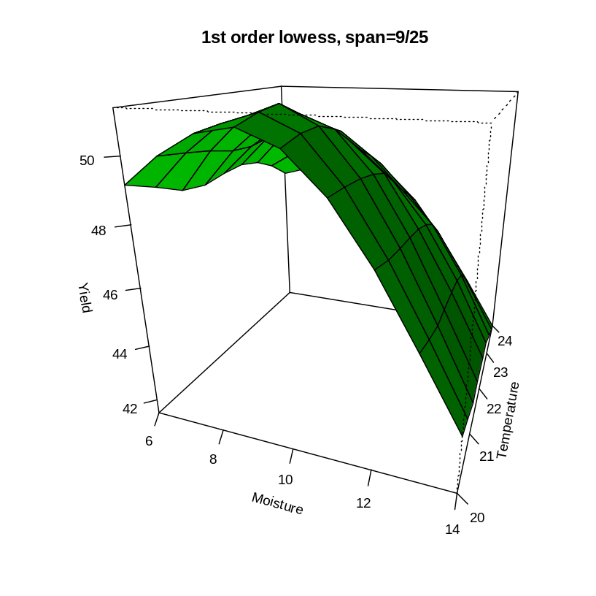

Overall, the lowess model plot looks similar to the regular least squares regression model plot. It would be nice if one could easily overlay the two in R to examine this more closely. I was unable to figure out how to do this in R. Instead, I copied and pasted the plots of the models on top of each other in PowerPoint (making sure the scales were exactly the same). While this is not the optimal way to assess the similarities of the models, it may be the best way to do it graphically outside of R. Note that the first plot below has the regular regression model in the background and the second plot below has the lowess model in the background. The images below are just PowerPoint slides.

